Considerations for Choosing a Transfer (Bath) Bench
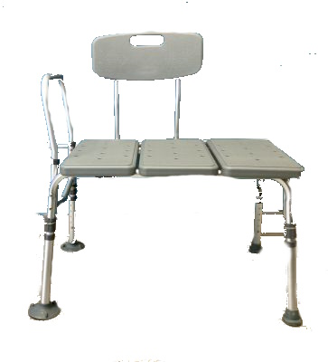
A transfer bench allows a person to sit down on the outside of the tub and then "scoot" over into the tub. The bench legs straddle the tub wall. Some transfer benches have a seat that slides over rails and can rotate. Some have a back and an armrest (on the tub side only). Most models have adjustable legs, useful for users of different heights and for leveling the bench, should the tub floor be higher than the bathroom floor. Padded models and bariatric models are available. Keep in mind that while the padding is more comfortable, it makes moving over the bench surface more difficult.
After you complete this self-assessment, use your answers to look at the inventory to see which chair or bench best meets your needs.

Transfer Bench Questions
- Is the intended user a child or an adult?
- Child
- Adult
- Why is your bath equipment no longer usable for you?___________________________

- What did/didn’t work well for the user? (Do you want to duplicate what you have or need additional features?) __________________________________________________

- Do you need to transfer to a tub, or would you prefer a shower seat?

- User’s approximate height and weight?
Height____________________ Weight____________________
- Do you want/need back support?
- Yes
- No
- Do you want/need padding?
- Yes
- No
- Do you want/need armrests?
- Yes
- No
- Do you want/need suction cups on legs?
- Yes
- No

