Considerations When Choosing a Shower Chair

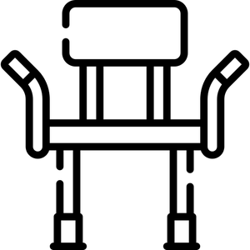
A shower chair is designed to allow a person to shower while seated. It may have a back and/or armrests. It may also be a stool with hand grips only. Shower chairs are also referred to as bath seats. Some are designed with legs for use in tubs, while others have wheels for use in roll-in showers. Tilt-in-space models are used for repositioning, and options in all models include seatbelts, commode openings, padding, armrests, footrests, and headrests.

After you complete this self-assessment, use your answers to look at the inventory to see which shower chair best meets your needs.

Questions
- Is the intended user a child or an adult?
- Child
- Adult

- Do you currently use a shower chair?
- Yes (if known, please indicate)_______________________________
- No (if no, proceed to question # 10)

- Is there a manufacturer sticker present?
- Yes (make, model)_____________________________________________
- No

- Why is your current shower chair no longer usable for you? ________________________

- What did/didn’t you like about your shower chair? (Do you want to duplicate what you have or need additional features?)____________________________________________

- Current shower chair seat width?
Seat Width__________inches

- Current shower chair seat depth?
Seat Depth__________inches

- Current seat to floor height?
Seat to Floor__________inches

- Current seat surface to the top of back height?
Seat to Back Height__________inches

- User’s approximate height and weight?
Height____________________
Weight____________________

- Do you have a roll-in shower or a bathtub (with or without sliding glass doors)?
- Roll-In
- Bath Tub with Sliding Glass Doors
- Bath Tub without Sliding Glass Doors

- Do you want/need a rolling, self-propelling, sliding, or tub chair with legs?
- Rolling (caregiver pushes)
- Self-Propelling
- Sliding
- Tub Chair

- Do you want/need a commode opening? If so, round or u-shaped (placement, Left, Right, Front, Rear)?
- No Opening
- Round Opening
- U-Shaped Left Opening
- U-Shaped Right Opening
- U-Shaped Front Opening
- U-Shaped Rear Opening

- Do you want/need tilt and/or recline seating function?
- Tilt
- Recline

- Do you want/need a seatbelt?
- Yes
- No

- Do you want/need a headrest?
- Yes
- No

- Do you want/need a sliding tub chair?
- Yes
- No

- Do you want/need suction cups on the legs?
- Yes
- No
- Do you want/need padded armrests?
- Yes
- No
- Do you want/need a transfer bench, and if so, which side will you transfer to (L/R)?
- Yes Left
- Yes Right
- No, Don’t Want/Need

