Considerations For Choosing a Scooter
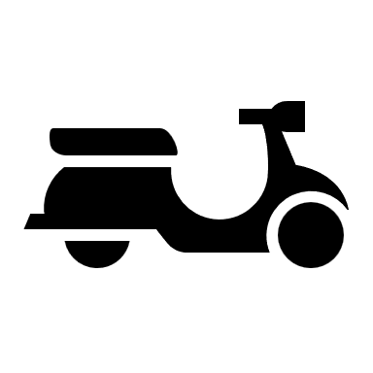
Powered scooters allow people who have difficulty walking to travel longer distances. They come in either 3 or 4-wheel models, and some are compact, making them easy to fold up and transport. However, all scooters are heavy. Their batteries weigh more than 30 pounds each, and they usually require two.

Three-wheel scooters have a tighter turning radius, but they are still awkward and can tip when turning. Four-wheel scooters are more stable, work best outdoors, and come in bariatric models. All scooters are plugged in to charge each evening and should not be stored outside. They require a dry heated environment.

While scooters are lighter and less expensive than power wheelchairs, they also do not provide seating support. Scooters require users to sit upright for long periods and to have the strength and dexterity to steer and use the controls.

Consider how much weight your scooter will carry before choosing a device. In addition to your own weight, keep in mind if you plan to carry shopping bags and/or oxygen tanks. Also, remember that scooter users may gain weight once they transition from walking to riding.

After you complete this self-assessment, use your answers to look at the inventory to see which scooter best meets your needs. If there is a scooter that is not appropriate for you or your environment, please don’t request it. Scooters are often requested but infrequently donated. If you need more information than is available at the listing, research the make and model online for its features, weight limits, and other specifications.

1. Is the intended user a child or an adult?
- Child
- Adult
- Do you currently use a scooter?
- Yes (if known, please indicate type)____________________________________
- No (if no, proceed to question # 9)
- Is there a manufacturer sticker present?
- Yes (make, model)_________________________________________________
- No
- Why is your current scooter no longer usable for you (batteries dead, too small/big, etc.)?
______________________________________________________________________
- What did/didn’t you like about your scooter? (Do you want to duplicate what you have or need additional features____________________________________________________
- Current seat width?
Seat Width__________inches
- Current seat depth?
Seat Depth__________inches
- Current seat to floor height?
Seat to Floor__________inches
- Current seat surface to the top of back height
Seat to Back Height__________inches
- User’s approximate height and weight?
Height____________________ Weight_________________________

- Is your home wheelchair accessible (ramp/lift vs. steps, bathroom, and interior access)?
- Yes
- No
- Do you drive your own vehicle or use public transportation?
- Drive my own vehicle
- Use public transportation
- Both

- Will the scooter be used primarily indoors or outdoors?
- Indoors
- Outdoors

- Do you prefer a 3 or 4-wheel scooter?
- 3 Wheel
- 4 Wheel
- No Preference

- Do you want/need an oxygen tank holder?
- Yes
- No

- Do you want/need a cane holder?
- Yes
- No

- Do you want/need a walker holder?
- Yes
- No

- Do you want/need a crutch holder?
- Yes
- No

- Do you want/need a basket?
- Yes
- No

- Do you want/need a safety flag?
- Yes
- No

- Do you want/need a light package?
- Yes
- No

- Do you want/need a rearview mirror?
- Yes
- No

