Considerations When Choosing a Power Wheelchair
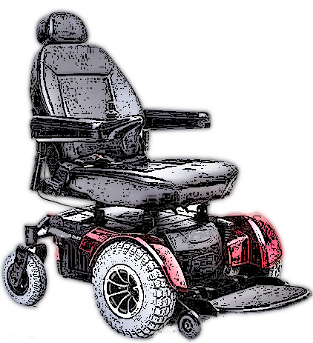
Power wheelchairs are used by individuals with disabilities who cannot operate or are easily fatigued by a manual wheelchair. The type of power wheelchair an individual requires can vary greatly, depending on functional limitations, medical conditions, usage patterns, and lifestyle. They range from basic models with captain’s seating (as seen in a van) with a simple drive control to complex systems with specialized seating and positioning and a controller for driving and repositioning.

Fit and accessories are usually determined during a seating evaluation with an occupational or physical therapist. You can try different models and components during this clinical evaluation to determine which best meets your needs. If you have never used a power wheelchair before, you are strongly advised to seek professional recommendations to ensure a safe and appropriate selection. The questions below are meant to help you review the devices in our inventory.

Questions
- Do you currently use a power wheelchair?
- Yes (if known, please indicate type) _______________________________
- No (proceed to question # 10)

- Is there a manufacturer sticker present?
- Yes (make, model)__________________________________________________
- No

- Why is your current power wheelchair no longer usable for you (batteries dead, too small/big, etc.)? ________________________________________________________________________

- What did/didn’t you like about your power wheelchair? (Do you want to duplicate what you have or need additional features?) ________________________________________

- Current wheelchair seat width?
Seat Width__________inches

- Current seat depth?
Seat Depth__________inches

- Current seat to floor height?
Seat to Floor__________inches

- Current seat surface to the top of back height?
Seat to Back Height__________inches

- User’s approximate height and weight?
Height____________________
Weight___________________

- Is your home wheelchair accessible (ramp/lift vs. steps, bathroom, and interior access)?
- Yes
- No
- Do you drive your own vehicle or use public transportation?
- Drive my own vehicle
- Use public transportation
- Both
- Do you use captain’s seating (fixed seating as in a van) or a removable cushion?
- Captain’s seating
- Removable Cushion (type if known)____________________________________

- Do you want/need a tilt and/or recline seating function?
- Tilt
- Recline
- Tilt and Recline

- Do you want/need a power seat elevator?
- Yes
- No

- Do you want/need a headrest?
- Yes
- No

- Do you have an armrest preference?
- Swing-Away
- Adjustable Height
- Padded
- Other
- Do you want/need a tray?
- Yes
- No
- What type of drive you prefer: rear, mid, or front?
- Rear
- Mid
- Front

- Type of controls you want/need: joystick or head/chin controls and left or right-sided joystick?
- Joystick Left
- Joystick Right
- Head or Chin Controls__________
- Sip’n Puff

- Do you have a leg rest preference-elevating, swing-away, power?
- Elevating
- Power Elevating
- Swing-Away

- Footrests-angle adjustable?
- Yes
- No

- Do you want/need calf pads?
- Yes
- No

- Do you want/need a seatbelt?
- Yes
- No

- Do you have a preference for either pneumatic or solid tires?
- Pneumatic
- Solid
- No Preference

- Do you want/need a transit option?
- Yes
- No

- Do you have a working charger?
- Yes
- No

