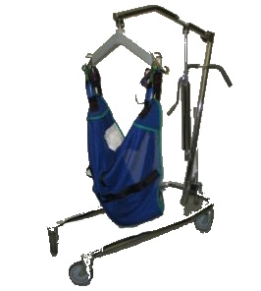
Considerations When Choosing a Mechanical Sling Lift
A mechanical sling lift (often referred to as a “Patient Lift” or “Hoyer Lift”) is a device that allows caregivers to safely transfer an individual between a bed, wheelchair, shower chair, or another surface. The most commonly used lifts are manual/hydraulic, but sling lifts also come in electric models. A sling lift is comprised of a base on casters, a boom, and a cradle that supports the sling. Bariatric models are available, and some lifts include a digital scale. Sling styles vary and include full-body slings, shower slings, toileting slings, and split-leg slings. Answer the questionnaire below to help you review the devices in our inventory.

Questions:
- Will the lift transfer a child or an adult?
- Child
- Adult
- User’s approximate height and weight?
Height_________________________ Weight___________________
- Do you currently use a mechanical lift?
- Yes (if known, please indicate type)_________________________________
- No (proceed to question #7)
- What did/didn’t you like about your lift? (Do you want to duplicate what you have or need additional features?)______________________________________________
- Is there a manufacturer sticker present?
- Yes (make, model)_______________________________________________
- No
- Do you want/need a manual/hydraulic or power lift?
- Manual/Hydraulic
- Power
- If you need new slings, what type do you want/need: mesh, vinyl, commode opening, full-body, padded u-sling, 4-point, or other?______________________________
- Do you need a scale attachment to obtain the weight of the person transferred?
- Yes □ No

