Considerations When Choosing a Gait Trainer
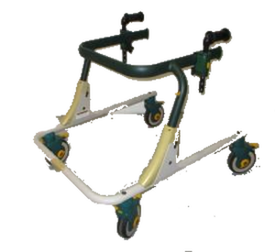
A gait trainer is a wheeled frame designed to provide upper body support as an individual acquires or regains the gait skills needed to walk independently. Unlike a standard walker, gait trainers offer numerous positioning and support accessories to support a person’s needs and goals. Gait trainers are best selected with guidance from a physical therapist. Size and weight capacity are essential considerations. Answer the questionnaire below to help you review the devices in our inventory.

Questions
- Is the intended user a child or adult?
- Child
- Adult
- Do you currently use a gait trainer?
- Yes (if known, please indicate type)__________________________________
- No (if no, proceed to question # 6)

- Is there a manufacturer sticker present?
- Yes (make, model)__________________________________________________
- No

- Why is your current gait trainer no longer usable for you?_________________________________________________________

- What did/didn’t you like about your gait trainer? (Do you want to duplicate what you have or need additional features?)____________________________________________

- Do you know the approximate elbow height (the vertical distance from the bent elbow to the floor while the user is standing upright)?
Height____________________
- User’s approximate height and weight?
Height____________________ Weight____________________

- If known, please indicate which of the following accessories you may want/need:
- Arm Prompts
- Hip Positioners
- Pelvic Harness
- Chest Prompts
- Thigh Prompts
- Ankle Prompts
- Hand Loops
- Hand Holds
- Communication Tray
- Guide Bar
- Other_____________________________________________________________

